POLITICS
Admission $15 per person includes a
™
Sack Lunch
PROPHECY
& THE SUPERNATURAL
PROPHECY CONFERENCE
The Coming Great Deception and the Luciferian End Game
Saturday June 6th, 2009 ∙ 9:00am – 6:00pm ∙ Doors Open @ 8:30am
The Renaissance Theatre 138 Park Ave. West Mansfield, OH 44902
You may purchase tickets by phone, in person at our box office, or on the website www.mansfieldtickets.com
Renaissance Box Office 419-522-2726 ∙ Weekdays 10am - 5pm
We would like to invite you to join us in an exciting one-time event.
This is an event you don’t want to miss, so purchase your tickets NOW! We are seeing a heightening of events in our Headlines, the forming of a One World Government, One World Religion, Economic Crisis, MidEast Peace, threat of a Nuclear or Biological war, the burgeoning UFO phenomenon, what is Hollywood preparing us for with recent movies such as, “Knowing”, “Race to Witch Mountain”, & “Watchmen”, Corruption, Violence, the Black awakening, the return of the Nephilim, and Genesis 6.
What does this all mean?
Do you wonder how these all fit together? Wonder no longer.
This is your chance to obtain an outpouring of Knowledge and Discernment from 3 outstanding speakers and authors who are considered experts in their field.

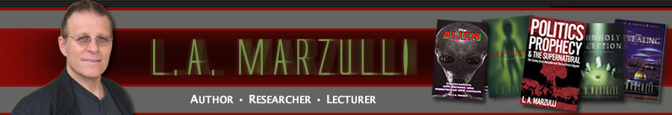
Our Keynote Speaker: Dr. L.A. Marzulli. He is the author of the Nephilim Trilogy. The Nephilim Trilogy made the CBA best sellers list. Marzulli received an honorary doctorate from Pacific International University for his work on the Nephilim Trilogy. Marzulli is also the author of the non fiction work, Politics, Prophecy & the Supernatural. The book packs a hard hitting expose of how the current political landscape may bring about ancient Biblical prophecies, which then may trigger supernatural events that are foretold in the book of Daniel and Revelation. His latest offering, The Alien Interviews, features 17 personal, intense interviews with people who have been directly involved with the UFO phenomena. The book was written for the skeptic with various world-views presented as to what these phenomena may be. Marzulli has lectured on this fascinating subject presenting his exhaustive research at conferences and churches as well as appearances and interviews on numerous national radio and television programs. Please check out his website: www.lamarzulli.net

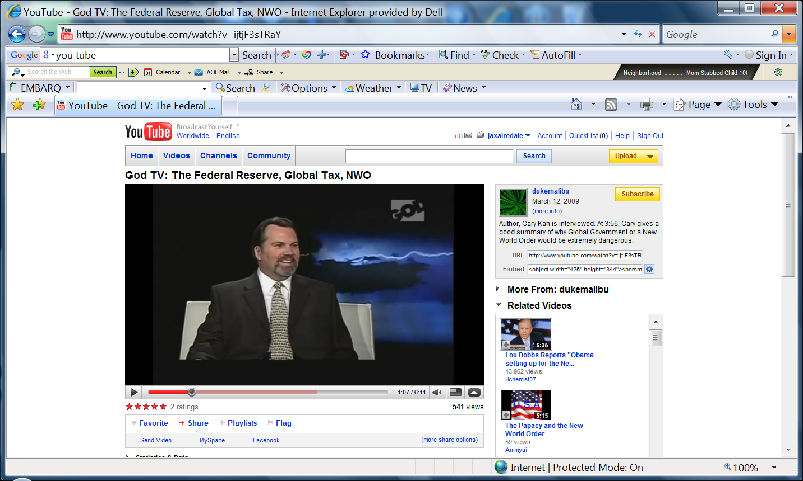
Gary Kah is the former Europe & Middle East Trade Specialist for the Indiana government. While in that position he traveled extensively overseas working closely with the economic staff at American Embassies on trade-related projects. During that time, he learned of efforts underway to establish a one-world political/financial system. He also discovered there was a religious motivation connected with these developments. Gary has written two best-selling books detailing his experiences and explaining the goals of the one-world/interfaith movement. His books, En Route to Global Occupation and The New World Religion, are fully documented and are critical in understanding today's global developments - including the current financial crisis. Gary keeps readers informed of the latest international economic, political and religious developments through his research news journal Hope for the World Update. Gary has appeared on over one thousand radio and television talk shows. Please check out his website: www.garykah.org/

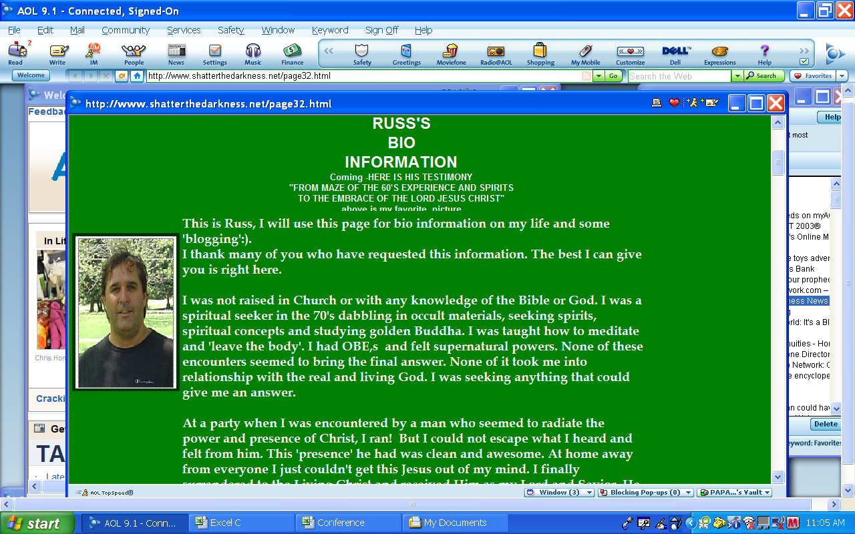
Russ Dizdar came out of the 60's as a dabbler in dark occultism and a practitioner of golden Buddha meditation he sought anything spiritual to find what it was he was looking for. Russ became a licensed and then Ordained minister on October 1978 reformation Sunday. He was also Exec. Director of Greater Akron Youth For Christ, a Police Chaplin. Founder and now directs Shatter the Darkness and Preemption Broadcast. Russ has studied at Emerge counseling center, Ohio Peace Officers Training Academy, DEFTEC law enforcement training in advanced occult and cult crimes. He has been to many training seminars on Satanic Ritual Abuse, SRA-MPD-DID, Mind Control, Spiritual Warfare, Abduction Research, Evangelism, Counseling, and other various fields. Russ will publish his first book this spring 2009 entitled 'THE BLACK AWAKENING' rise of the satanic super soldiers. See www.theblackawakening.com. Also check out his website: www.shatterthedarkness.net/

Please prayerfully consider joining us to seek God’s truth together!

